To Received their 1099s landlords must create or have created an online portal account.
Once you log in, you need to click My 1099s in the tan box on the left.
They then click the black arrow (>) next to Lansing Housing Commission Year 2021 Address 419 Cherry

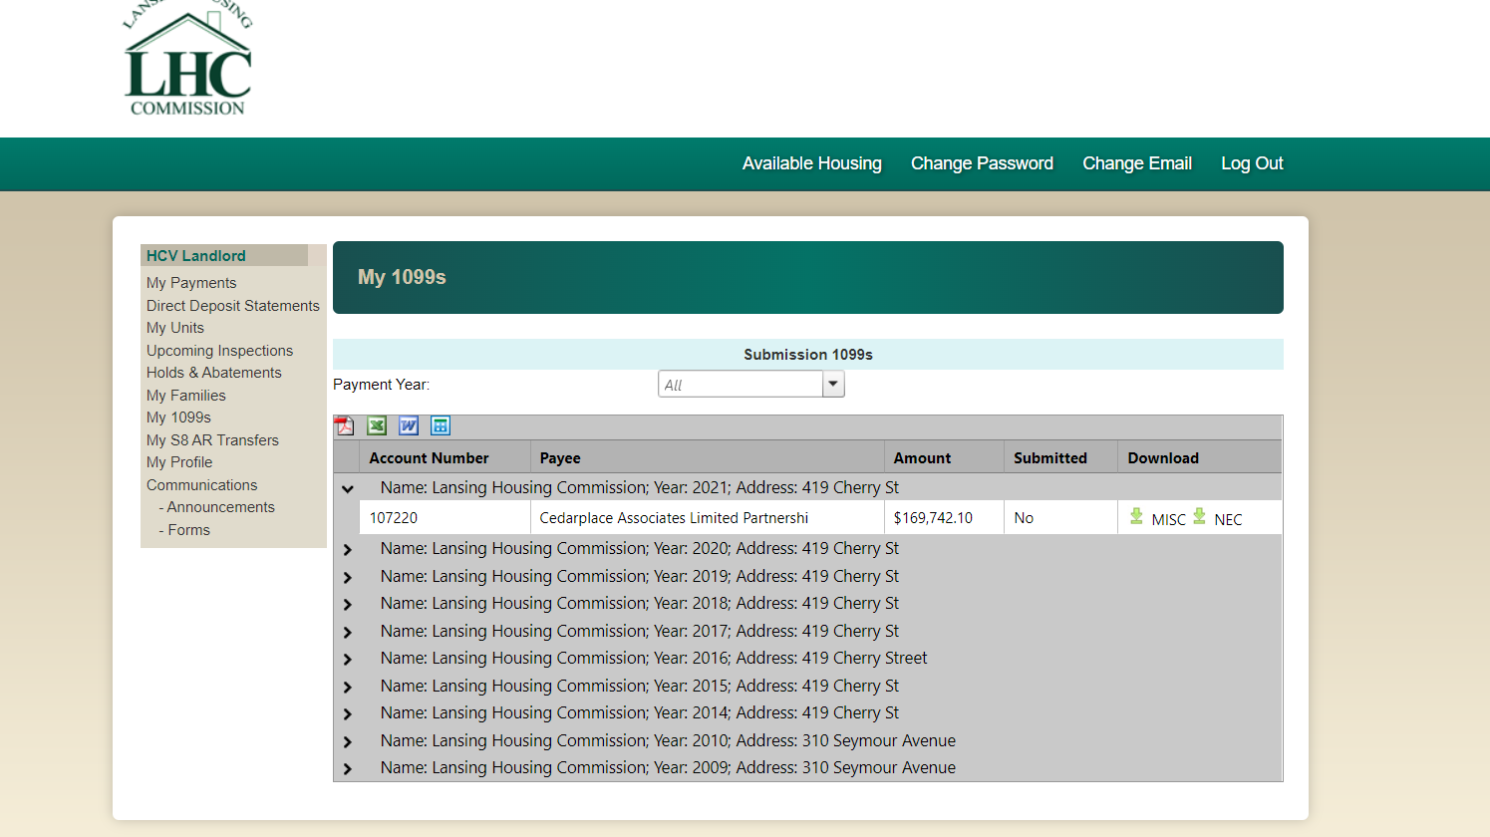
Next click on MISC under the Download column
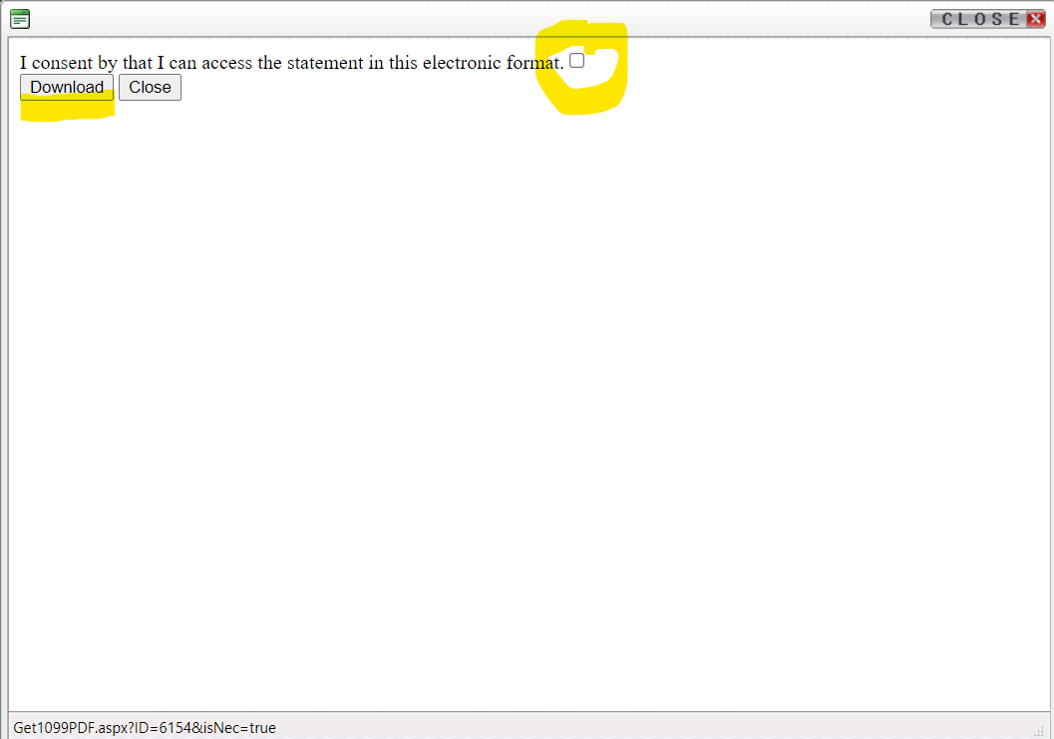
The above screen will pop up. You must click on to create at check mark before they click Download
The 1099 will pop up, and you can save it to your device or print it.

